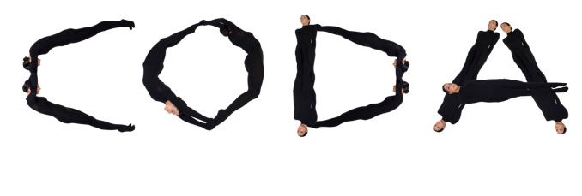

APPLICATION „CODA 2019“

(separate form fore ach dance has to be filled out)
(to be fiiled out in capital letters)

NAME OF THE GROUP /
NAME OF THE SOLOIST
NAME OF THE TEACHER
DANCE CATEGORY |  | Tick the box if the dancer is using pointe shoes
AGE GROUP
NAME OF THE DANCE
NAME OF THE AUTHOR
LENGTH OF THE DANCE (min., s)
NUMBER OF THE DANCERS
TELEPHONE
EMAIL

TOTAL NUMBER OF THE PARTICIPANTS FROM THE GROUP
(to follow total number of the diplomas and gifts. To be filled out only in one form)

